- Run command to start docker container
docker-compose -f mysql.yml up
- Visit http://localhost:8080/ in browser to access Adminer
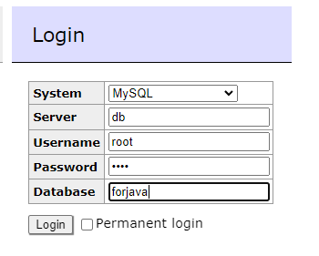
- After getting login
